PROFILE
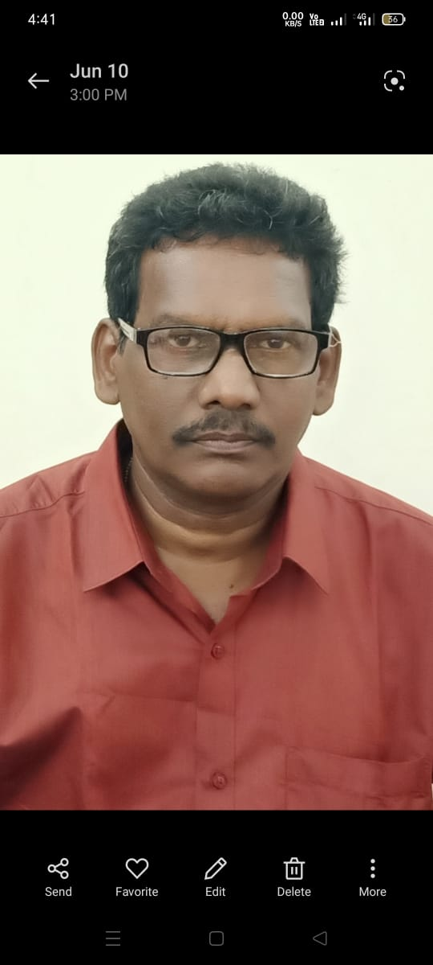
Photo

Name : G Govinda Rajulu
Designation : Lecturer

College : Government Degree College
Address : Paderu, Alluri Sitharama Raju Dist

DOB : 01/06/1965
E Mail : govindaraju.sharmilakumari.000@gmail.com

Qualifications

Degree | DD/MM/ YYYY | Name of the Institute | Class Obtained | University
B. A (OL) | 1987 | Matrusree oriental college | II nd | Achary nagarjunaUniversity
M A Telugu | 1993 | Achary nagarjunaUniversity | IInd | Achary nagarjunaUniversity

Total Experience with details

Date of joining into Service : 5th August 2005

Date of Joining into Present Institution : 21-06-2017

Teaching Experience : 19 Years

S.No | Teaching Experience in Year and Months | Name of the college
1 | 2005-2011 | Mr Govt. Sanskrit College
2 | 2011-12 | Dr. V S Krishna GDC Visakhapatnam
3 | 2012-13 | GDC Chintapalli
4 | 2013-2015 | GDC Sabbavaram
5 | 2015-2017 | GDC Chintapalli
6 | 2017- till today | GDC paderu

Presentation of Papers in Conferences/Seminars

Sno | Title of the Paper | Seminar/Conference | Organised Institution | Mode
1 | - | - | - | -

Research area :
Papers Published :

S.No | Title  of Paper | Name of Journal | ISBN/ISSN | Year of Publication | SCOPUS/Inter nation al/UGC Approved | Impa ct Fact or
1 |  | - | - | - | - | -
2

Professional Development

Number of Orientation Courses, Induction Programmes Attended

S No | Name of the Programme | Organization | Duration | MODE

Number of Refresher Courses Attended

S No | Name of the Programme | Organization | Duration | MODE

Number of Short Term Courses Attended

S  No | Name of the Programme | Organization | Duration | MODE

Department Tests GO & EO Completed

S NO | Name of the Test | Date of Qualifying
 | - | -

Online FDP Programmes attended:

S.No | Name of the Programme | Organization | Date
1 | HVPE 5 Days residential | CCE | 05/12/2022 to 10/12/2022
2 | Internship learning management system | CCE | 03/02/2023 to 04/02/2023

Seminars/Webinars organized

S No | National/Intern ational | Name of Seminar/Webi nar | Name of the Institution | Date of Conduction | MODE | POSITIO N
 | - | - | - | - | - | -
Seminars /Webinars Participated

S  No | Name of Seminar/Webinar | Name of the Institution | Date of Participation | MODE
 | - | - | - | -

Workshops attended:

Sno | Name of the Workshop | Name of the Institute | Date of  Participation | Mode
 | - | - | - | -

